**JavaScript and CSS**

**Review of the DOM**

* What is “the DOM”?
* Browser objects: The browser has a set of built-in objects (in addition to JavaScript’s built-in objects)
  + The object tree: Objects are arranged in a hierarchy: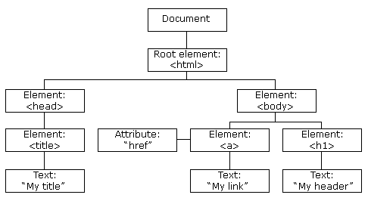from: <https://www.w3schools.com/js/js_htmldom.asp>
  + Referencing objects:
    - By HTML Object Collections
      * Colledtions in the DOM
      * Accessing a single element
        + By the array index  
          collection[idref]

Example:  
<img src="dog3.png">  
<script>  
var number = prompt("Please enter a number from 1 to 5");  
document.images[0].src = "dog" + number + ".png";  
</script>

* + - * + By the element id  
          collection.idref
    - By tag name:  
      (this will return an array)  
      var paragraphs = document.getElementsByTagName("p");
    - By element id attribute:  
      document.getElementById("message").innerHTML = "Hello DOM!";